Segmented Europeanization
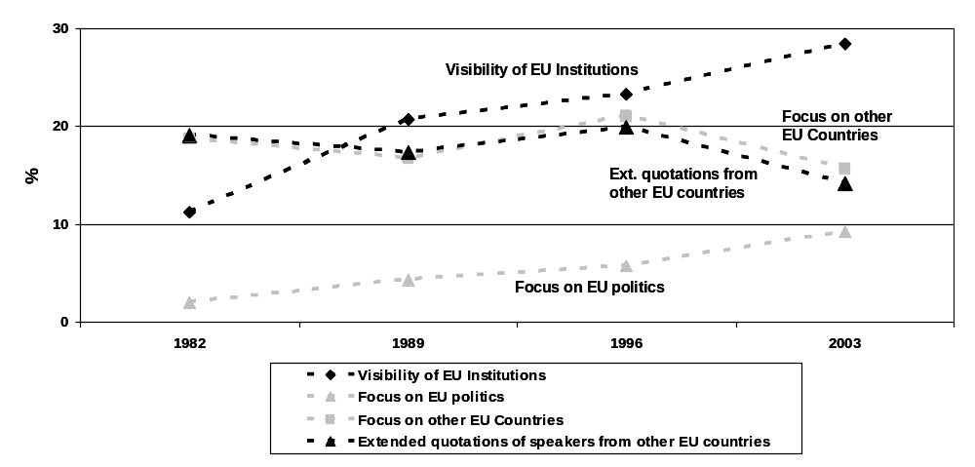
EU institutions and EU politics are clearly discussed more intensively over the past two decades (vertical Europeanization) while other European countries and speakers from those countries do not get more attention (horizontal stagnation).
This analysis is based on roughly 3000 opinion articles in Le Monde (France), Frankfurter Allgemeine Zeitung (Germany), The Times (Great Britain), Politiken (Denmark) and Die Presse (Austria).

